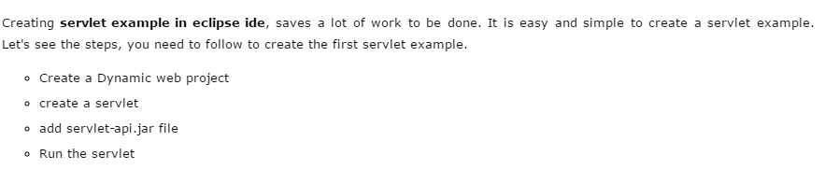

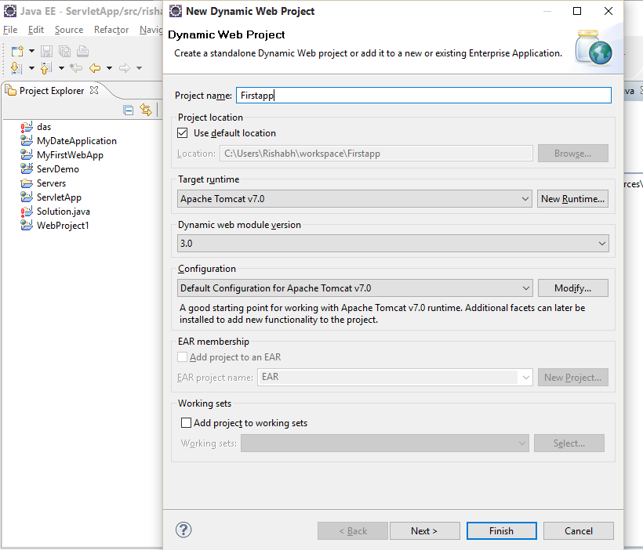

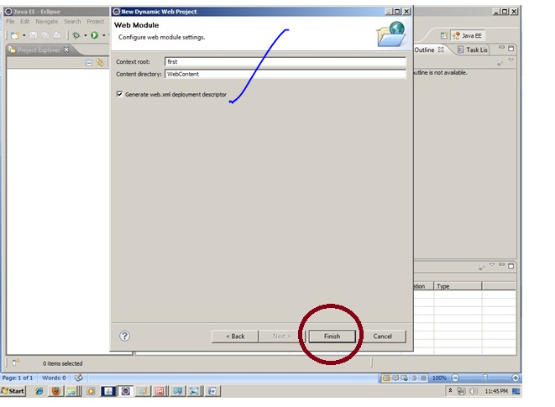

### 2) Create the servlet in eclipse IDE:

For creating a servlet, **explore the project by clicking the + icon -> explore the Java Resources -> right click on src -> New -> servlet -> write your servlet name e.g. Hello ->**

**uncheck all the checkboxes except doGet() -> next -> Finish**.

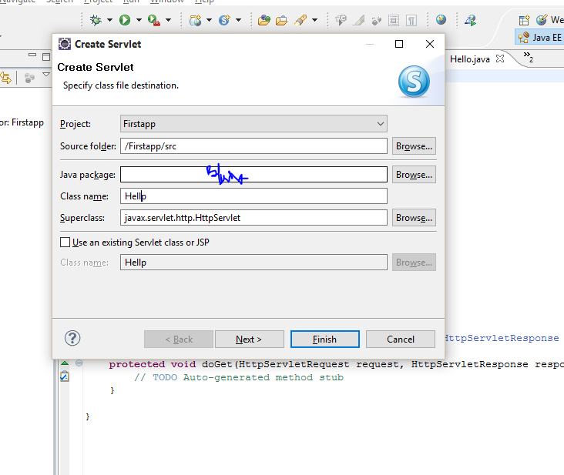

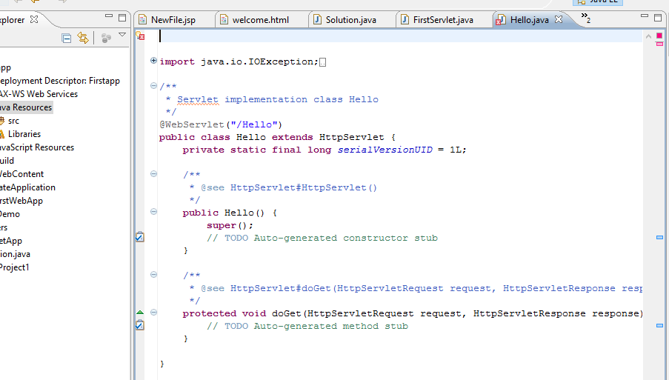

### add jar file in eclipse IDE:

### or adding a jar file, right click on your project -> Build Path -> Configure Build Path -> click on Libraries tab in Java Build Path -> click on Add External JARs button -> select the servlet-api.jar file under tomcat/lib -> ok.

### 

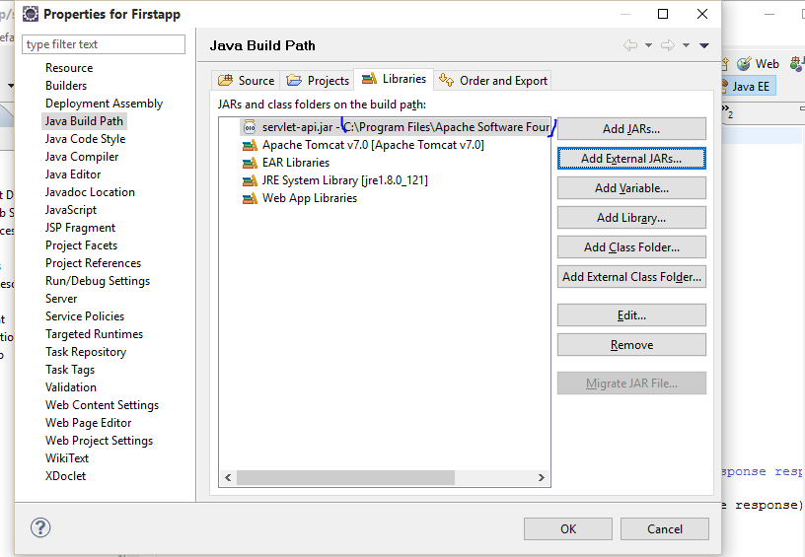

Now servlet has been created, Let's write the first servlet code.

Then define the method of doGet->

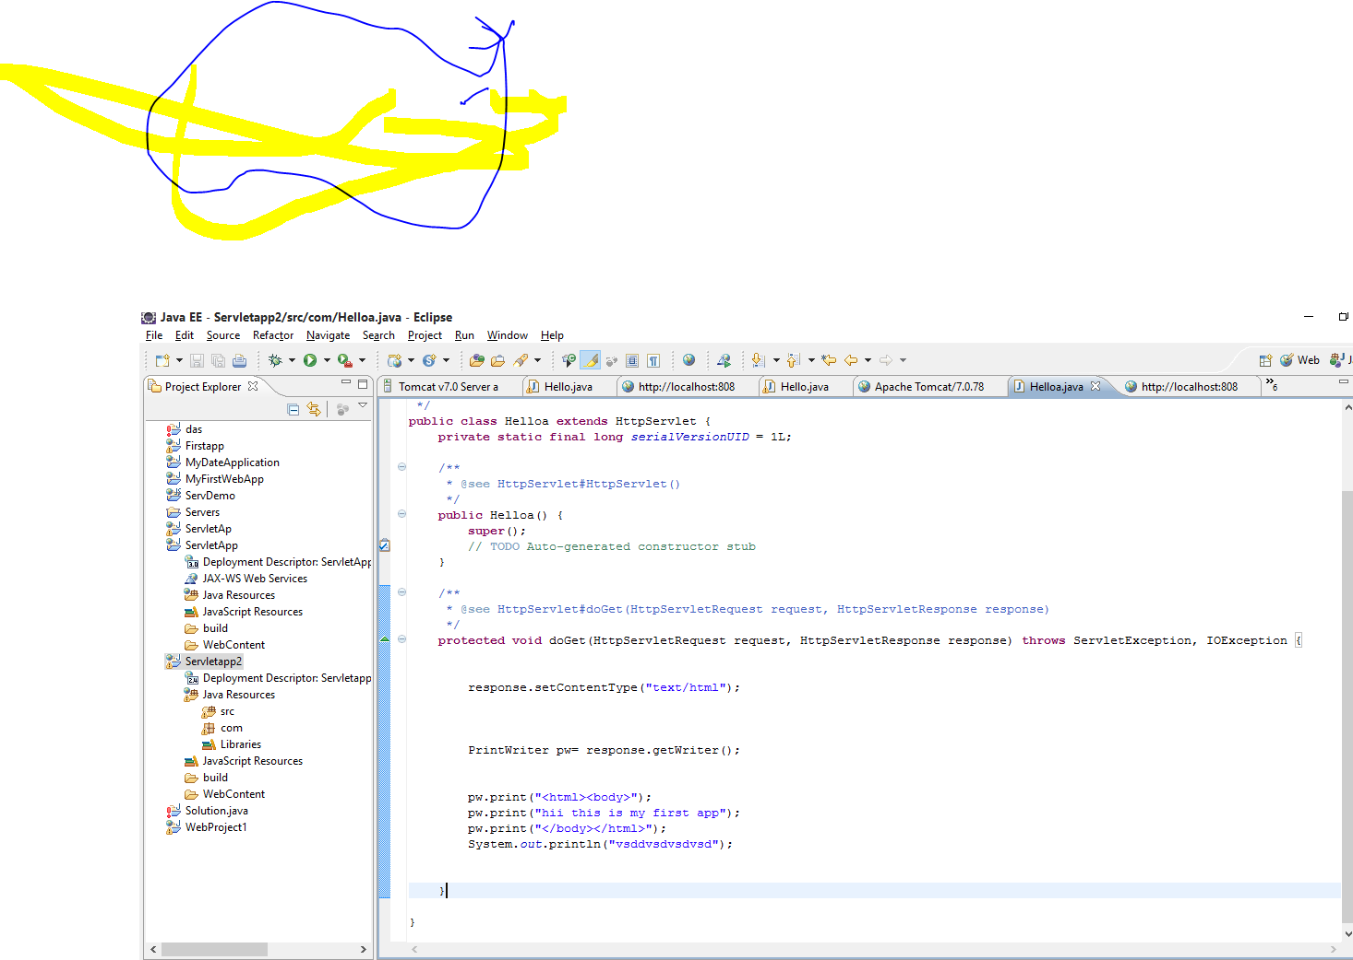

Now run on server->

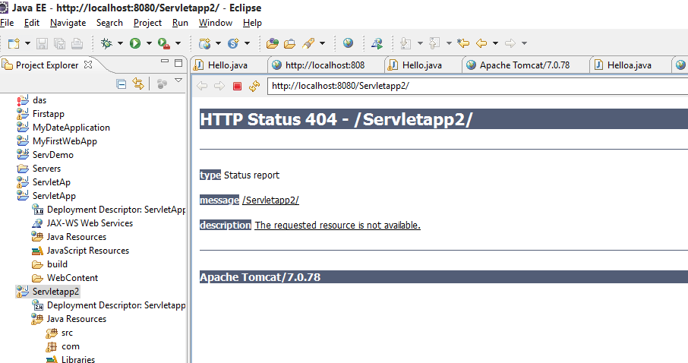

This will come after running on server/

Then in url paste the servlet name

